Topic: Mobile App Prototype

Tripti Vishwakarma
Colorado State University Global
Course Code: CSC 505-1
Jonathan Vanover
Jun 2 2024

For the architectural design, I would use UML (Unified Modeling Language) to represent the different components and their interactions within the app. Here's a basic overview:

1. Use Case Diagram: This will outline the different interactions between users and the system. For instance, users can create a shopping list, add items to it, remove items, mark items as purchased, etc.

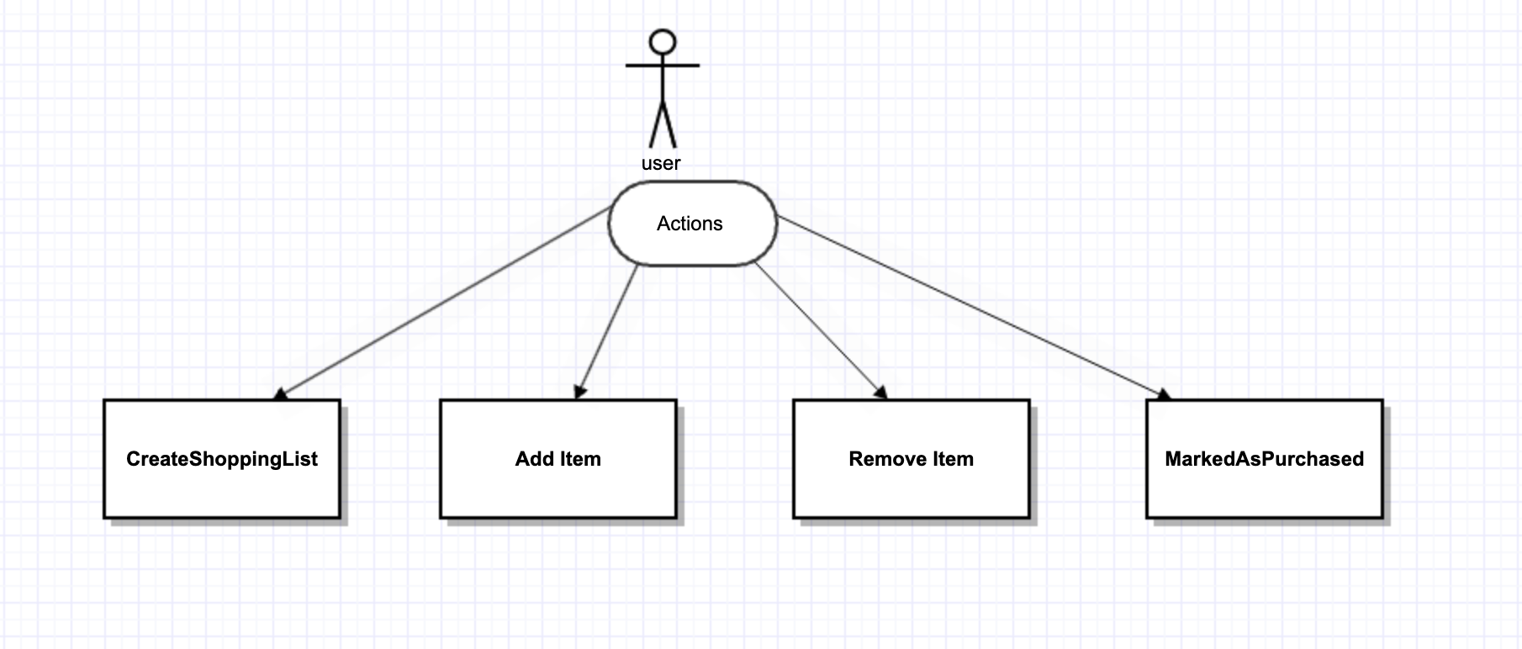

2. Class Diagram: This will show the different classes in the system and their relationships. Classes might include User, ShoppingList, Item, etc.

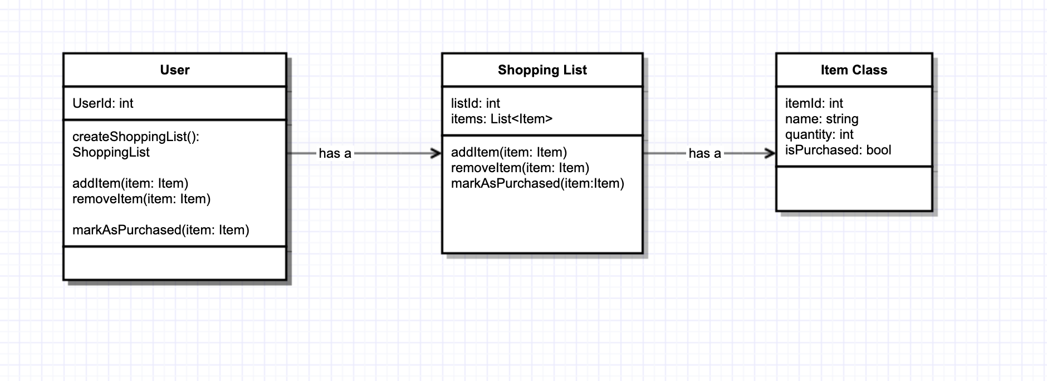

3. Sequence Diagram: This will depict the sequence of interactions between different components when a user performs a specific action, such as adding an item to the shopping list.
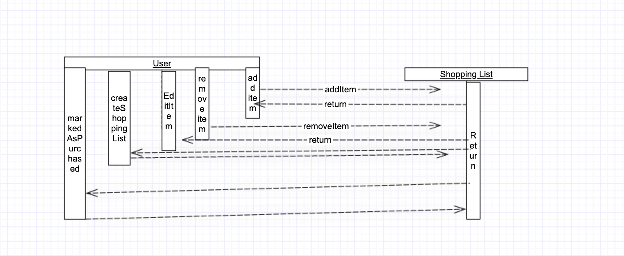

4. Component Diagram: This will show the different physical components of the system and how they interact.

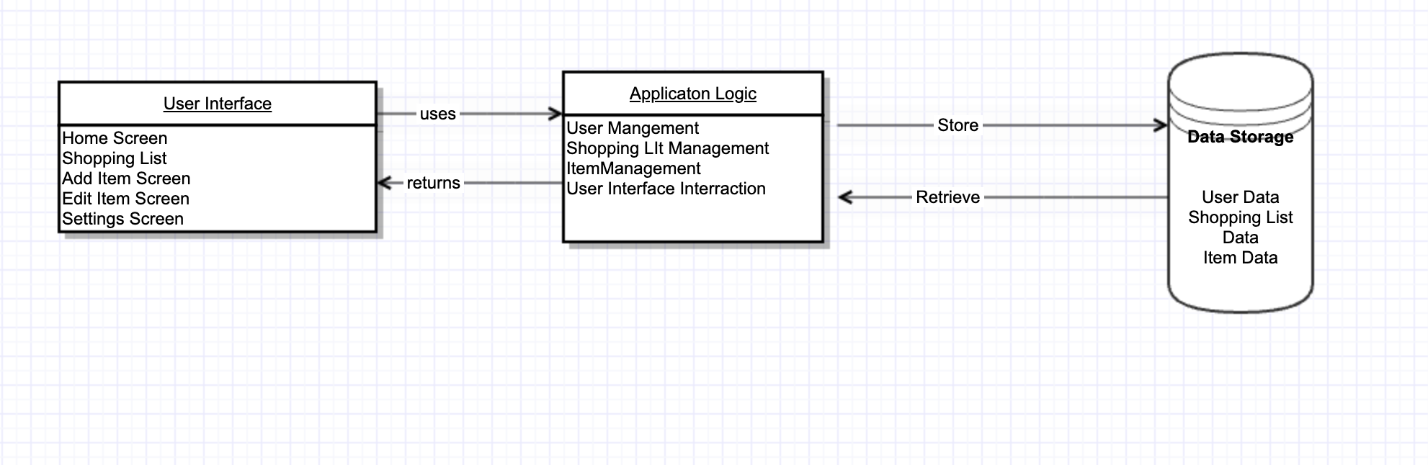

For the paper prototype here are sketches of the key screens:

Home Screen: This is where users can see their existing shopping lists and have options to create a new one or select an existing list.

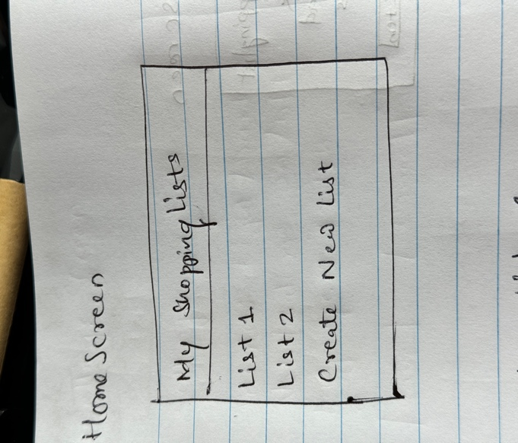

Shopping List Screen: Once a list is selected, users see a screen listing all the items on that list with options to add, remove, or mark items as purchased.

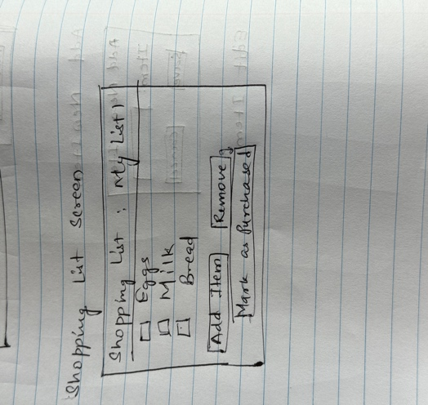

Add Item Screen: When users want to add a new item to the list, they see a screen where they can input the item name, quantity, and any other relevant details.

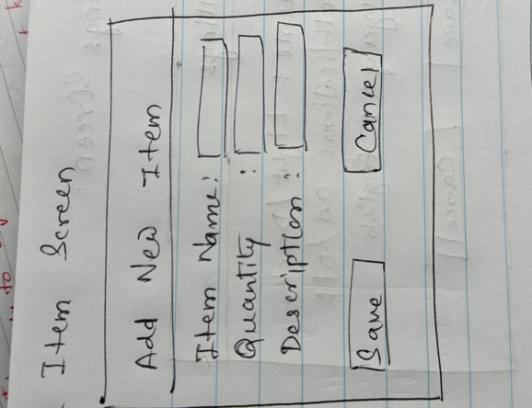

4. Edit Item Screen: Users can edit the details of an existing item on the list, such as changing the quantity or notes.

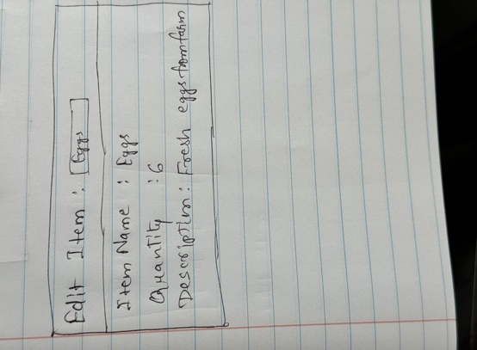

5. Settings Screen: Here users can access app settings, such as themes, notifications, etc.

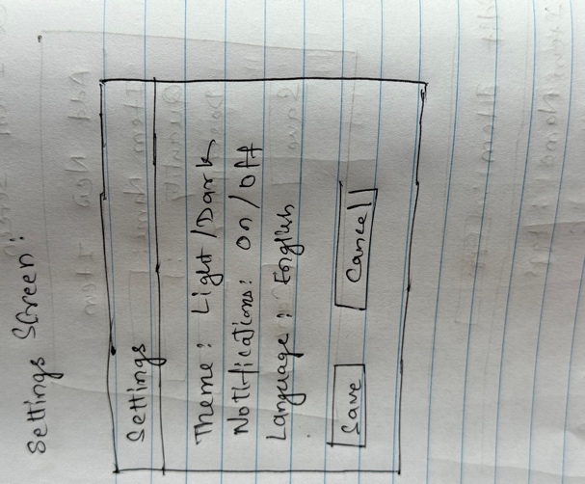

Below is the Python script to print out the prototype details:

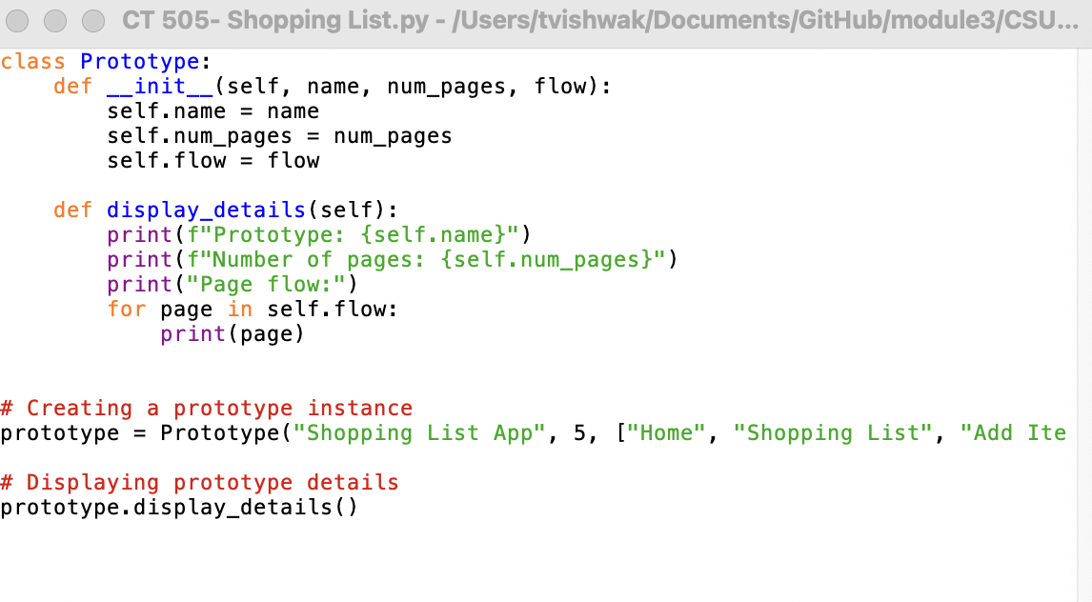

Execution of above script-

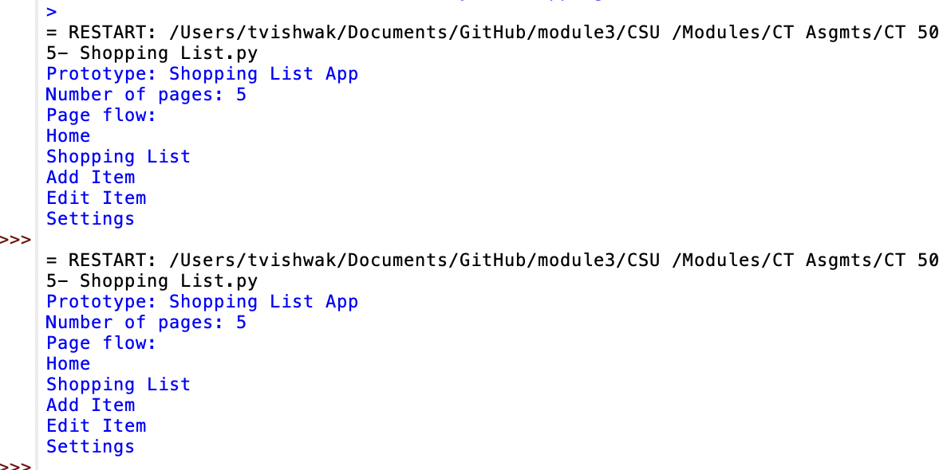

This demonstrates a simple representation of the prototype with its pages and flow sequence.

Prototypes are important in giving a team a preview of the software. They assist the stakeholder in moving from a statement of general objectives to the level of detail that developers need to create the desired functionality.
The development team should use the first prototype as a proof of concept. An accurate prototype shows that the initial architectural design is the right approach to getting to the required functionality and to satisfying the customer’s performance constraints. Working with a functional prototype suggests that requirements engineering, software design, and software development should proceed in parallel.

References-
Dr. Vanover, Module 3 Prototypes and Prototype Evaluation.
(2001). Manifesto for agile software development. https://agilemanifesto.org/
Pressman, R., & Maxim, B. (2020). Software engineering: A practitioner’s approach (9th ed.). McGraw Hill.
What is Prototyping? Definition, Types, Qualities and more- https://www.geeksforgeeks.org/what-is-a-prototype-and-how-to-create-it/
Medium.com , What is a mobile app prototyping- https://medium.com/@addevice/what-is-a-mobile-app-prototype-9dd05aafae32

